The iPad

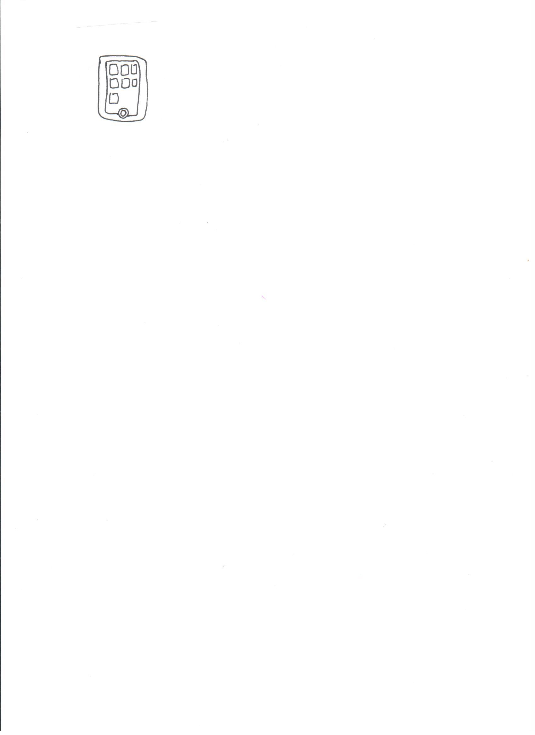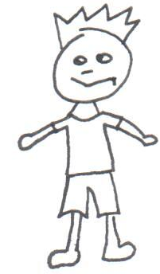

by: Andrea Chouhan
http://greenbeankindergarten.wordpress.com

Tad is mad.

Tad
Dad is mad too.

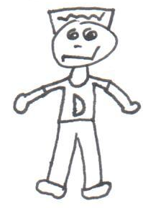
mad

Tad had an iPad.

iPad

It was bad.

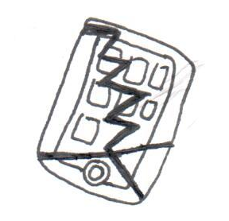

bad

Tad and Dad are sad.

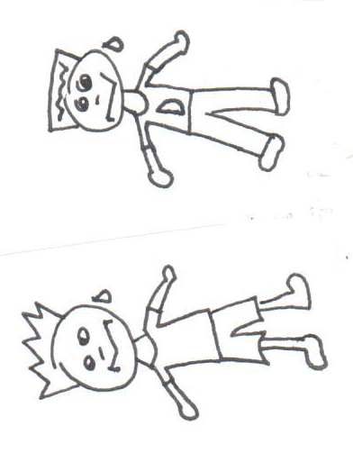

Tad Dad

Too bad!

The end.

