He Ate Hay
By: Andrea Chouhan

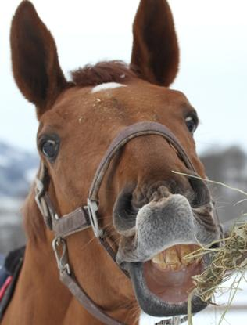

Henry ate hay.
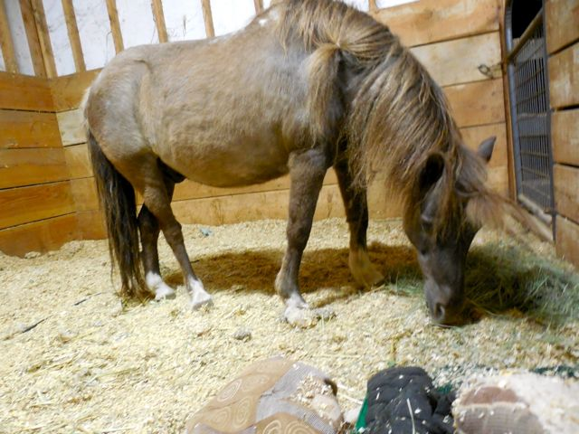
Henry ate hay, all day!
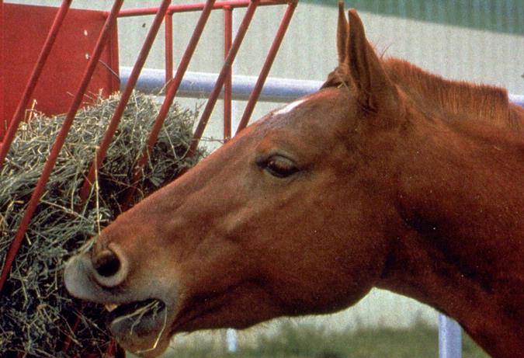

He ate and ate and ate!
Now he has to nay all day.
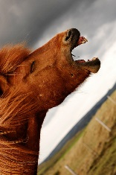

Now he has to lay all day.
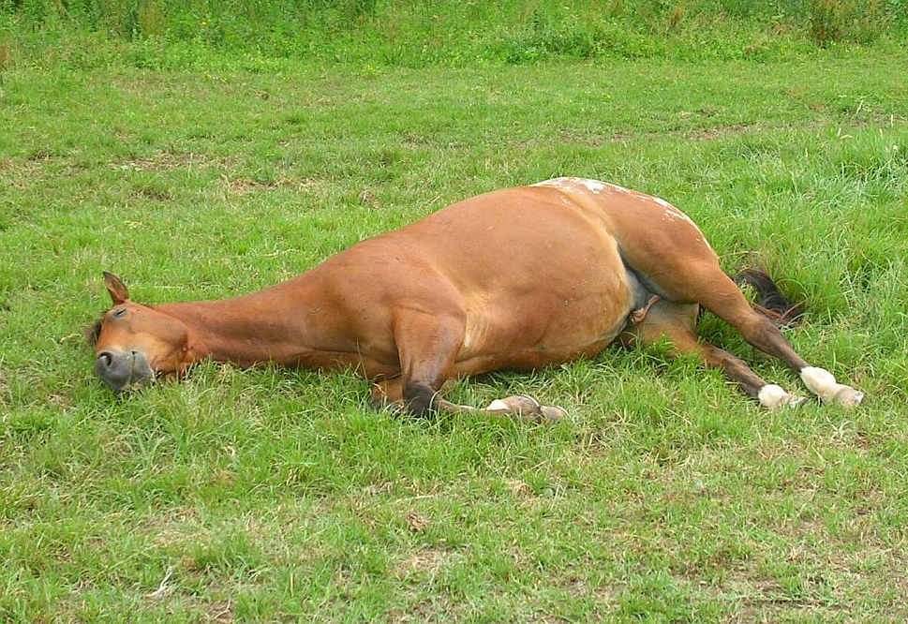

The end.

Teacher and Parent Tips:
Before the child reads the page, have him look at the picture and talk about what he sees. At the end of the story, ask the comprehension questions.

Comprehension Questions:
- What is the horses’ name?
- Is the horse a boy or girl? How do you know?
- Why does Henry look like that?
- What is Henry Doing?
- Why did Henry Nay?
- How do you think Henry is feeling when he nay’s?
- Why did Henry lay down?

