The Pup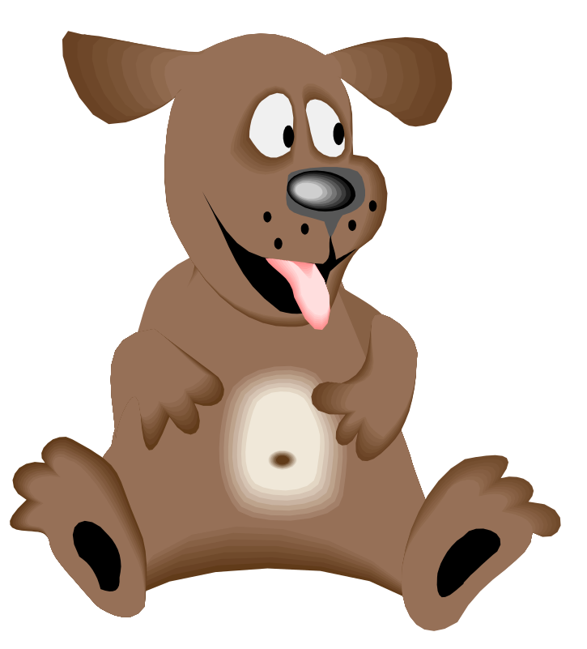

by: Andrea Chouhan
http://greenbeankindergarten.wordpress.com
This is my pup.

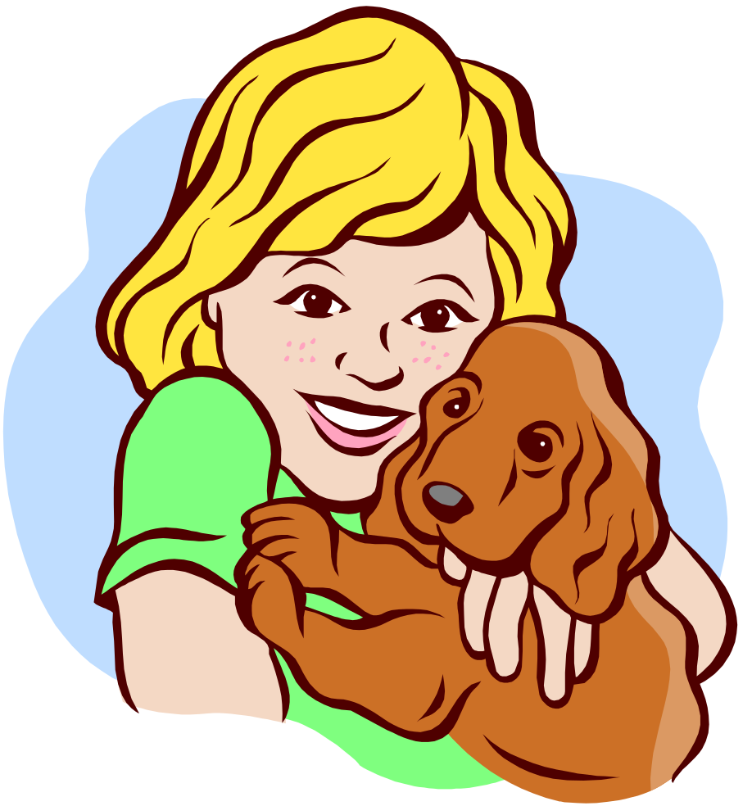

My pup is up!

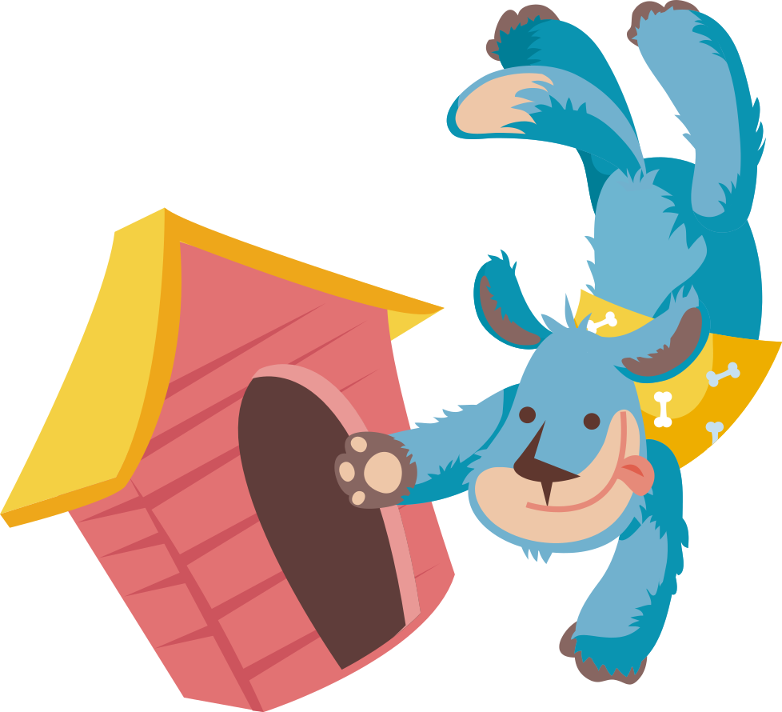

His cup, cup, cup...

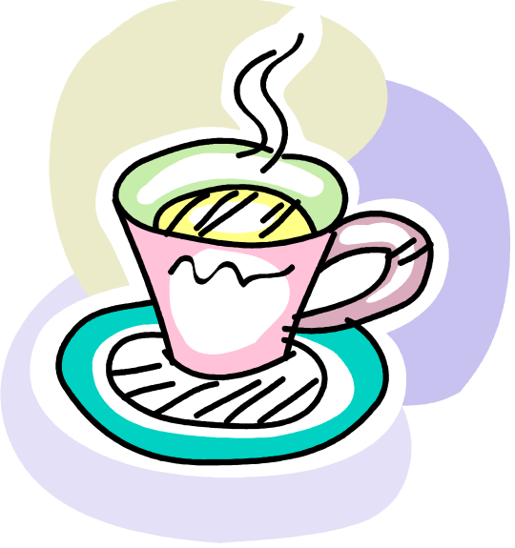
is up, up, up!
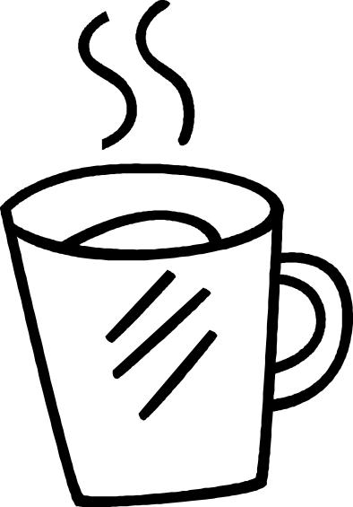



No, no, no Pup!

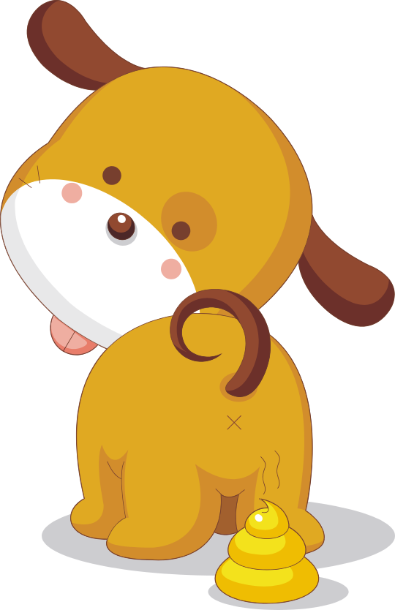

The end.

Comprehension Questions:

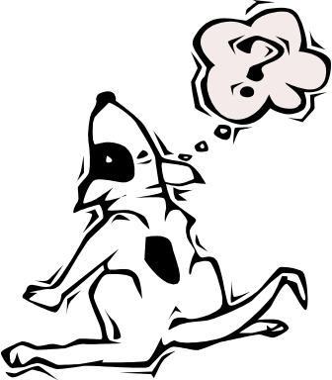

- What was your favorite part of the story?

- Who is the story about?

- Can this story really happen?

- Which words in the story, rhyme?

