This week in Kindergarten, we worked on reading and writing words that contain the sight word “am.” We made the words: ham, jam, Sam, Pam, ram. Your child chose the letter to write what best fit the picture beside it. Have your child read these words to you today!
r j h S P

 | __am
 | __am
 | __am
 | __am
 | __am

Mmmm…..Jam!
Name:____________
Sight word focus: is, and, like
Word family: -am
http://greenbeankindergarten.wordpress.com


This is Sam.

This is Pam.
Sam and Pam like jam.
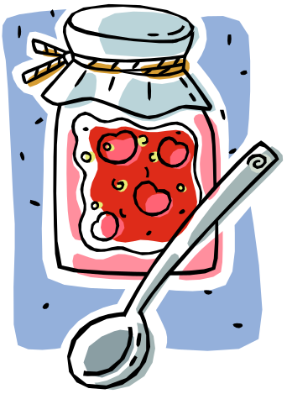
Sam and Pam like ham.
Mmmmmm…….
ham and jam!
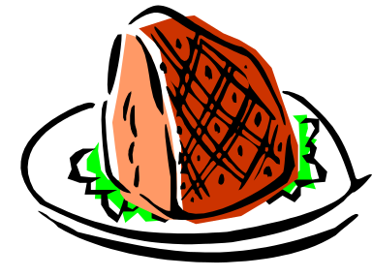

Sam | Pam | a | S
ham | jam | m | P
ram | like | j
and | is | h
This | . | r

 | 
 | 

Guided Reading Lesson Plan
Book: “Mmmm….Jam!”
CVC Word Cards: Sam, Pam, ham, ram, jam, Pam
Sight Word Cards: is, like, and, this
Letter Cards: a, m, j, h, r, S, P
Picture Cards: ham, Sam, jam, Pam

Monday: Introduce letter cards. Have children find the letter that was named. Say a letter and have them write the letter on paper or whiteboard. Have partners match letter cards with one another.
Tuesday: Match letter cards as a review from yesterday. Now focus on letter sounds. Touch each letter and say its sound. Now, say the sound while the students find the letter cards that makes that sound. Write the letters on a whiteboard while saying the sound.
Wednesday: Make words using letter cards. Then write words on Word worksheet. Use word cards to help make words. Match picture cards to word cards. Read sight word cards.
Thursday: Review from yesterday making words and matching word cards to picture cards. Find words in book and read them. Listen and/or read book with the teacher.
Friday: Read all word cards. Find each word in the story. Now, read the story by pointing to each word. Read book to partner and take turns reading.
Homework: Take word cards and book home. Practice above activities at home.

