Welcome to
café dunn

Math Menu
1 2 3


You are the chef of Math
and will choose a Math
recipe below. What
would you like to make?

Created by: Andrea Chouhan
achouhan1@kleinisd.net
2. Domino Little Book or cards

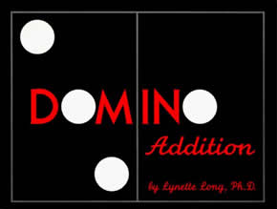
On each page, draw dominos and add together the dots. Write the sentence on each page like this.

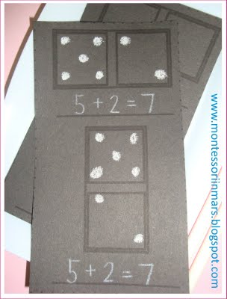
Five and two make seven.
___ and ___ make ___.

3. Lego Words

Make short or long words with Legos. Make your name with Lego’s too! Try to draw what you made.

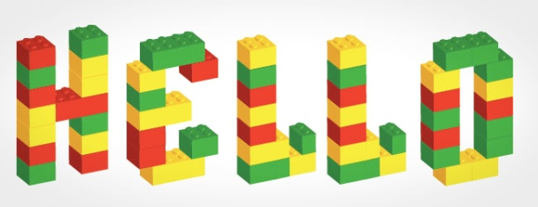

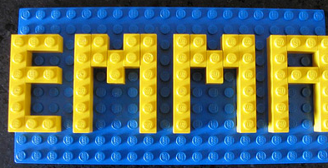

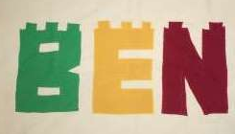

1.“Ten Black Dots” book or picture

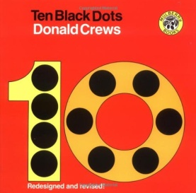
Read the book then make your own pictures with black dots. Write down what you made. You could also make an “8 Black Dots” or “13 Black Dots” book.
